The 3rd Conference on Communication, Culture and Media Studies (CCCMS) 2016
Type your title, capitalize only the first letter

Abstract
It should consist of one paragraph, 100 - 250 words. The abstract should be in Times New Roman 9 points and justified. The abstract states briefly the purpose of the research, method, the principal results and major conclusions. An abstract is often presented separately from the article, so it must be able to stand alone. For this reason, references should be avoided. Also, non-standard or uncommon abbreviations should be avoided, but if essential they must be defined at their first mention in the abstract itself.

- Introduction
Here introduce the paper, put the background of the study. The accepted papers are published in the Proceedings. We wish to give the proceedings a consistent, high-quality appearance. We therefore ask that authors follow some basic guidelines. In essence, you should format your paper exactly like this document. The easiest way to use this template is to replace the content with your own material. Please do not alter the formatting and style layouts which have been set up in this template document.
  - Text length, structure and format
Papers should be in 5 – 7 pages including abstract, diagrams, tables and references. The papers should be divided into some sections: introduction, method, result and discussion, and conclusion.
File must be in MS Word only. The page should be in A4 format, with left and right margin 2,5 cm, upper and bottom margins 2 cm. The font should be Times New Roman 10 point, single space paragraph, justified. The paragraph should be started with an indentation. Do not add number pages, header and footer.
  - Section and heading
Heading could only be in two levels, namely section heading and sub-section heading. Section headings should be Times New Roman 12 point, left justified, bold, numbered consequently, with the first letter capitalized, starting with the Introduction. Sub-section headings should be Times New Roman 10 Point, left justified, italic, numbered 1.1., 1.2., etc, with the first letter capitalized. Only put the capital in the first letter of every section and sub-section heading. Bulleted lists may be included and should look like this:
- First point
- Second point
- And so on
  - Table and figure
Tables and figures must be embedded into the text and not supplied separately, placed close to the relevant text (or where they are referenced in the text). Every table and figure should have a caption, be numbered with Arabic numerals (1,2,3...).
All photographs, schemas, graphs and diagrams are to be referred to as figure. Figure should be placed at the top or bottom of a page wherever possible, as close as possible to the first reference to them in the paper. However, if two images fit next to each other, these may be placed next to each other to save space. The figure caption should be Times New Roman 9 point, numbered, bold, left justified and placed beneath the figure. Below is an example which the authors may find useful.

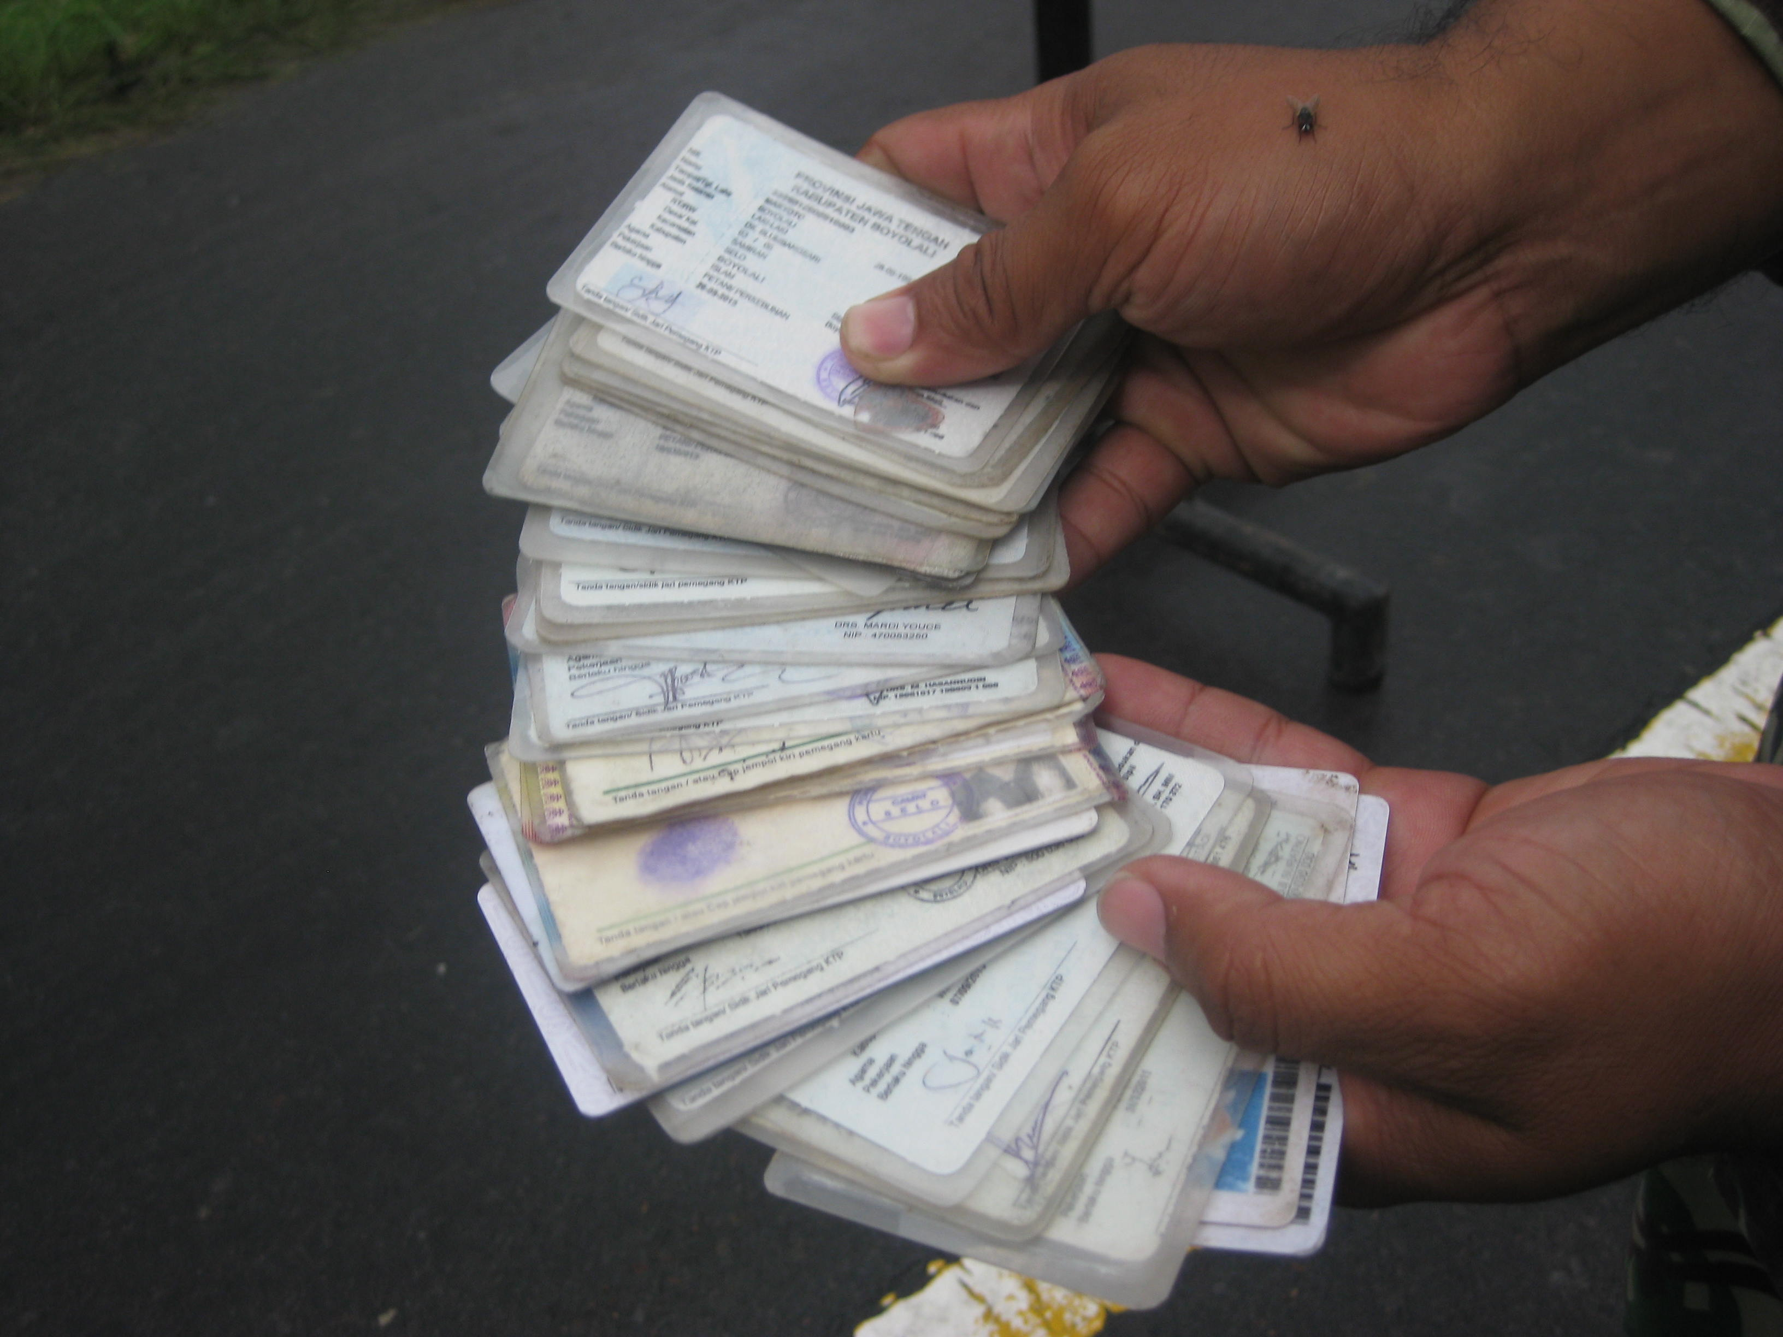
Figure 1. Example of figure

The table should be managed so it could be in one page, not separated into two pages. Only horizontal lines should be used within a table, to distinguish the column headings from the body of the table, and immediately above and below the table. The text in the table should be Times New Roman point 9, left justified. Table heading should be placed above table, numbered, Times New Roman 9 point, bold and centered. Below is an example which the authors may find useful.
Table 1. Example of table
Example of a column heading | Column A (t) | Column B (t)
An entry | 1 | 2
Another entry | 3 | 4
And another entry | 5 | 6
  - File naming and delivery
Please title your file in this order ‘Last name of first author_CCCMS_2016’. Example: Nazaruddin_CCCMS_2016.

2. Method

Explain the method of study clearly for every step, such as sample and population, informant selection, data collection, and data analysis.
- Result and discussion
The result and discussion could be combined in one section, or two sections as well, namely: 3. Result, 4. Discussion. This section should be the longest section of the paper, could consist of some sub-sections.
- Conclusion
State briefly the principal results and major conclusions. The section could also mention social, cultural, or political implications of the study. Do not add any new ideas or discussion here.
Acknowledgements
Acknowledgements heading should be left justified, bold, Times New Roman point 10, with the first letter capitalized but have no numbers. Text below continues as normal.

Reference

References and citations should follow APA style. References must be listed at the end of the paper. Do not begin them on a new page unless this is absolutely necessary. Authors should ensure that every reference in the text appears in the list of references and vice versa. Footnote should be avoided. References should be Times New Roman point 9, single space, justified, alphabetical ordered.

Indicate references in the text by:
- Underwood and Findlay (2004) studied… or (Underwood & Findlay, 2004).
- Hu et al. (2004) emphasized… or (Hu, Wood, Smith & Westbrook, 2004).
- The direct quotation should be like this. Nazaruddin (2015: 6) said, “Recent development occurred in the last five years is a mixture of angkringan and café: a half angkringan, a half café”.

Example of reference:

Cummings, J.N., Butler, B. & Kraut, R. (2002). The quality of online social relationships. Communications of the ACM, 45(7), 103-108.
Hu, Y., Wood, J.F., Smith, V. & Westbrook, N. (2004). Friendships through IM: Examining the relationship between instant messaging and intimacy. Journal of Computer-Mediated Communication, 10(1), 38-48.
Tidwell, L.C. & Walther, J.B. (2002). Computer-mediated communication effects on disclosure, impressions, and interpersonal evaluations: Getting to know one another a bit at a time. Human Communication Research, 28(3), 317-348.
Underwood, H. & Findlay, B. (2004). Internet relationships and their impact on primary relationships. Behaviour Change, 21(2), 127-140.

